Title: Lottery Scheduler
Name: Kadiatou Diallo
Class: CIS 345
Date: 5/16/2026
Prof: Yanilda
Introduction
This project implements a Lottery Scheduler in the xv6 operating system.
Lottery scheduling allocates CPU time probabilistically based on the number
of tickets assigned to each process. Processes with more tickets receive
more CPU time. The project required modifying the xv6 scheduler, implementing new system calls, tracking process statistics, and analyzing scheduler fairness using graphs.

Objectives: to Understand xv6 kernel structure, learn how CPU scheduling works, implement a Lottery Scheduler, add new system calls and Analyze scheduler fairness.

System Calls Implemented

settickets () The settickets () system call sets the number of tickets assigned to the calling process.

The getpinfo () system call returns scheduling statistics for all
processes, including:
- process ID
- ticket count
- tick count
- process usage status

Kernel Modifications

The process structure was modified by adding two fields:
tickets: stores number of lottery tickets
ticks: stores how many times the process was scheduled

allocproc (): Default values were initialized when a process is created

fork (): Child processes inherit the same number of tickets as their parent Scheduler Algorithm

The scheduler first calculates the total number of tickets for all runnable processes.
A random number is generated between 0 and the total number of tickets.
The scheduler iterates through all runnable processes and accumulates
their ticket counts.
The process whose ticket range contains the winning ticket is selected
to run.

Test Program

Three CPU-bound processes were created with ticket ratios 30:20:10.
Each process continuously executed an infinite loop to compete for CPU time.
The scheduler statistics were collected using getpinfo ().

Result Analysis

The process with 30 tickets received the highest number of CPU ticks.
The process with 20 tickets received a moderate number of ticks.
The process with 10 tickets received the lowest number of ticks.
The results closely match the expected proportional distribution of CPU time,
demonstrating that the Lottery Scheduler behaves correctly.

The graphs clearly show that processes with more tickets receive
more CPU time. The CPU allocation follows the expected 3:2:1 ratio.

Conclusion
The Lottery Scheduler was successfully implemented in xv6.
The scheduler correctly allocated CPU time proportionally according
to the number of tickets assigned to each process. Experimental results and graphs verified the fairness and correctness
of the scheduler implementation.

Screenshot
Kernel/proc.h
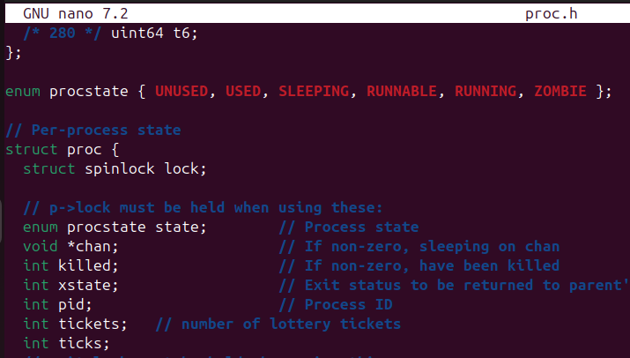
kernel/proc.c fork()
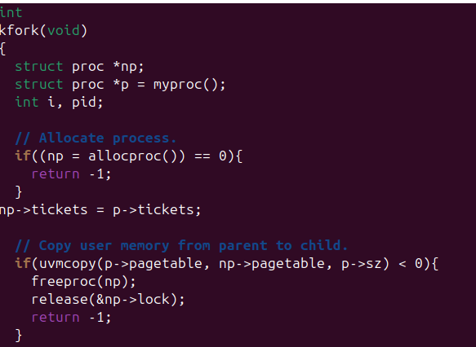

kernel/proc.c allocproc

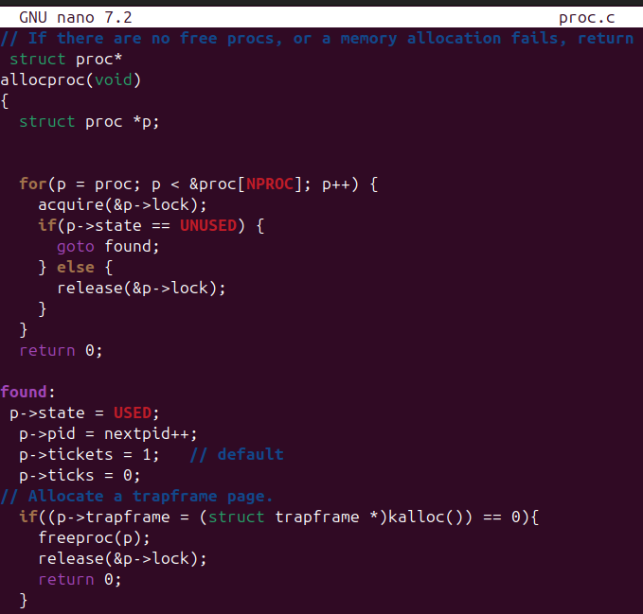

scheduler
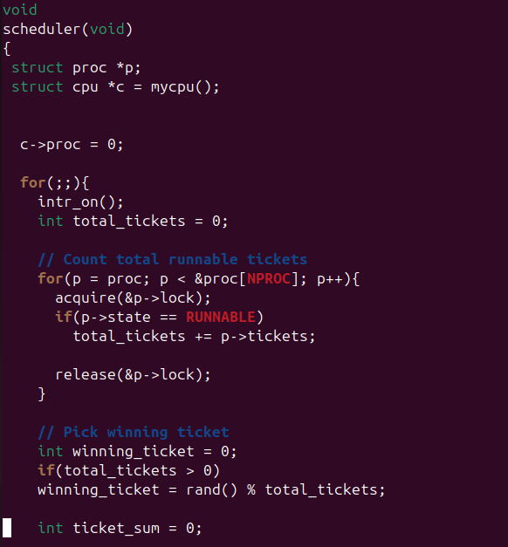
Kernel/sysproc.c
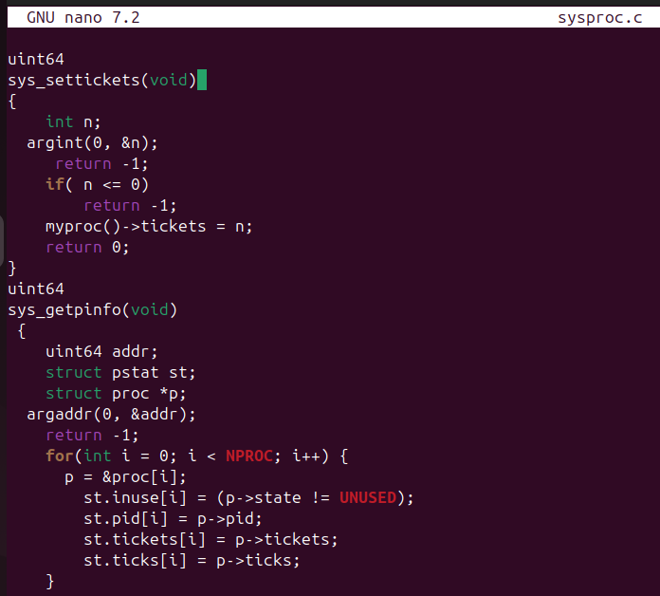
kernel/syscall.h
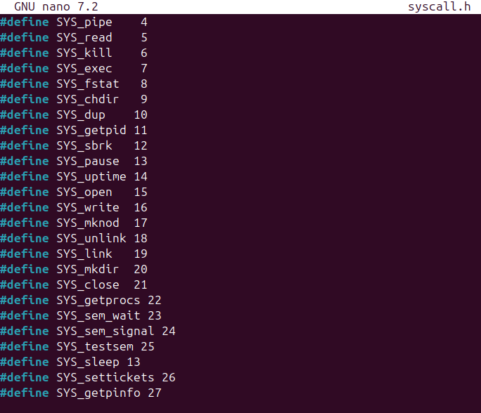
Syscall.c
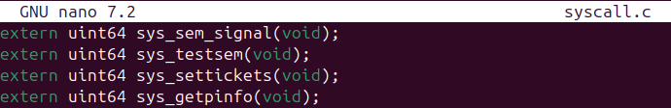
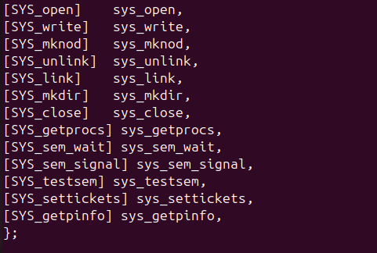

Lotterytest
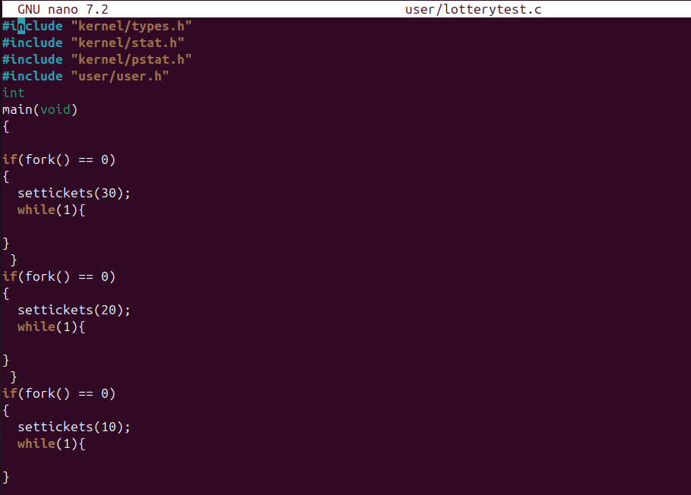

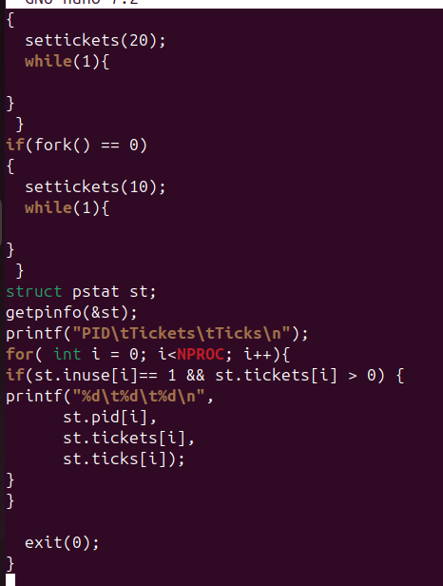
Makefile
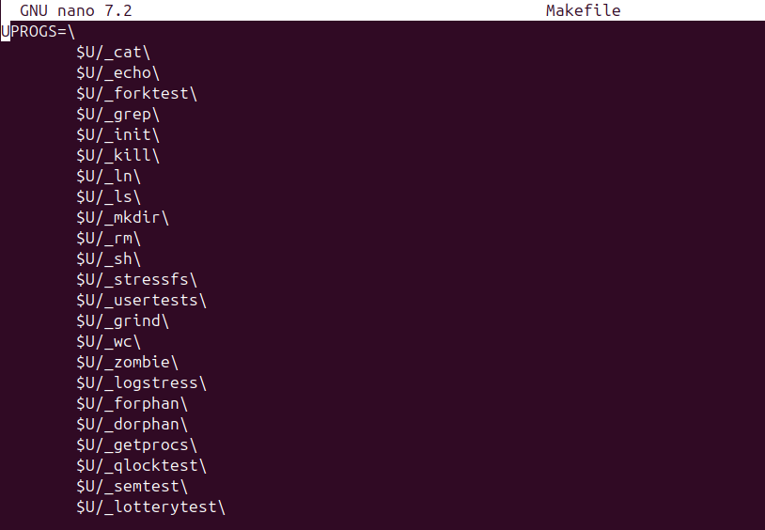
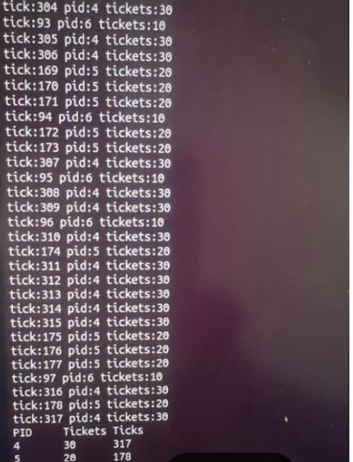

Graph

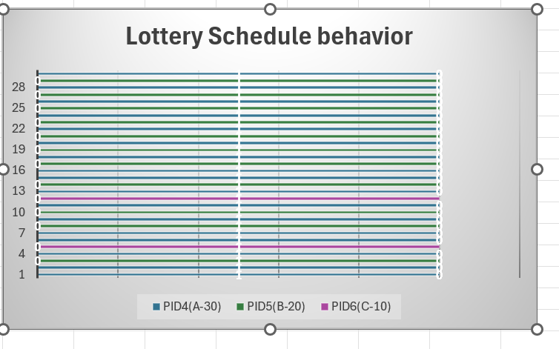

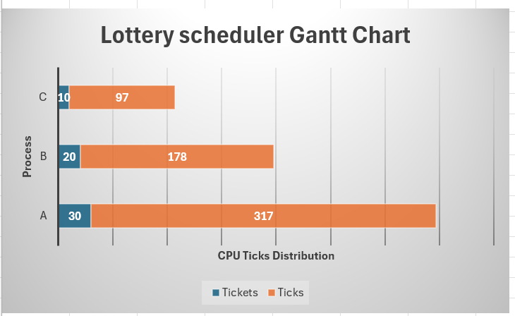

Three processes were executed using a lottery scheduler with ticket ratios 30, 20, and 10. The scheduler selected processes according to their ticket probability. The results showed that the process with 30 tickets received the highest CPU time (317 ticks), the process with 20 tickets received moderate CPU time (178 ticks), and the process with 10 tickets received the least CPU time (97 ticks). This demonstrates that the lottery scheduler distributes CPU time proportionally to the number of tickets assigned to each process.

